CONFERENCE
Enabling the Civic Space for Freedom of Expression, Freedom of Assembly and Association
July 21, 2017 Kyev

Follow-up activities plan

1. Creation of the FaseBook group for Black Sea NGO Forum WG on Human rights and Freedoms and invite to join it all participants of the Conference; creation of the e-mail Google-group for Black Sea NGO Forum HRF WG members, including participants of the Conference as a Platform for communication and sharing information and data.

2. Preparation and signing of the Memorandum of Partnership among organisations and civic activists of the Black Sea region on common actions for defending and advocationg human rights and freedomns in whole Black Sea region.

3. Continue the process of identification of stakeholders for networks and potential partners, on four main areas: minorities, children, women and vulnerable groups, as well as of identification of national context, best practices and main problem on the pointed problems in each countries, and last but not least – of identification of the calendar of Working meetings and sessions of intergovernemntal and international organisations with possible personal participation during their meetings.

4. Continue to work over increasing the number of members of the Black Sea NGO Forum WG on Human Rights and Freedoms and its on-line platforms.

5. Fundraising for making the Black Sea Conference on Human Rights and Freedoms annual.

6. Fundraising for publishing the materials of the Conference (Presentations, Human Rights Watch report, Resolution of the Conference, Memorandum of Partnership) in a brochure before the next Black Sea NGO Forum and disseminating those both during the Forum and during other similar events, such as the EaP Civil Society Forum Annual Assembly, EaP Youth Conference, Ministerial Platforms 1 and 4 meetings.

7. Follow-up session of the Conference at the next edition of the Black Sea NGO Forum – 2017 to be organised in order to support the sustainability of the regional cooperation initiative.

FUNDED BY:
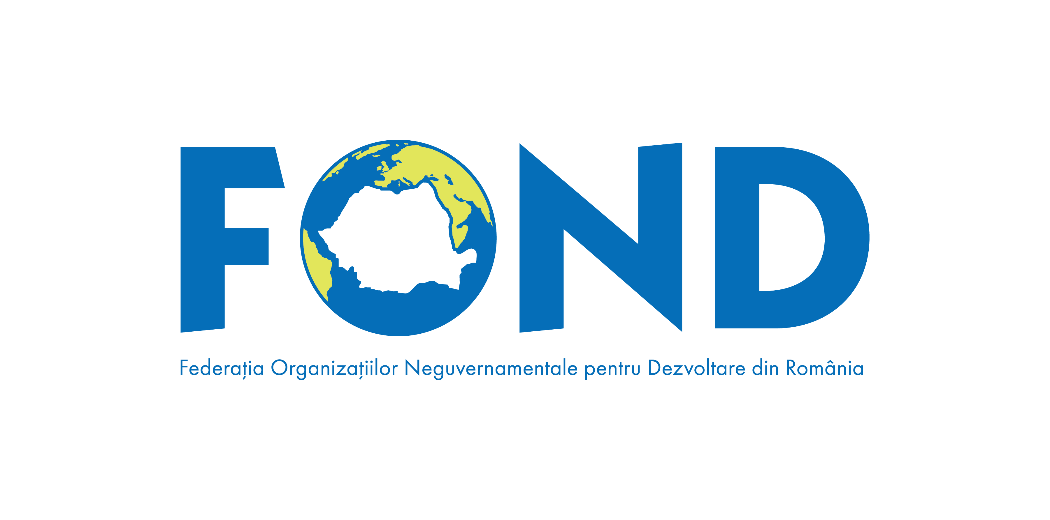
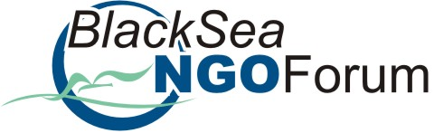
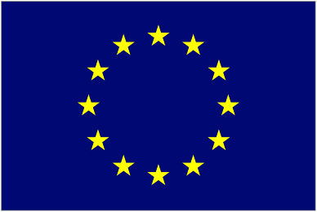

This regional thematic meeting is part of the follow-up activities of the 9th edition of the Black Sea NGO Forum, organised by the Romanian NGDO Platform – FOND, with the financial support of the European Commission, the Romanian Ministry of Foreign Affairs in partnership with UNDP Regional Center for Europe and Central Asia, and CSO Partnership for Development Effectiveness – CPDE.

